**Structural Engineering II (CE302) Project**

Semester V

B. Tech

Civil Engineering

IIT Guwahati



TITLE: Warehouse Modelling & Structural Analysis

**Submitted by-**

1. PRANAY KUMAR PARATE – 210104070
2. BAISHALI BORAH – 210104029
3. SHIKHA SINGH – 210104097
4. STELLA ANTONY – 210104107
5. MOUSAM KUMARI – 210104060

INTRODUCTION:-

A Steel warehouse is a structural building, which is used by industries to store raw materials and the produced ready goods. Steel warehouse is also called as the industrial building. There are two types of industrial buildings such as normal type of industrial building and special type of industrial building. Normal type of warehouses are the simple roofed structures on the open frames. Special type of industrial warehouses are such as cold storage buildings, etc. In the steel buildings such as the warehouses, the beams and columns are of steel sections of different sectional dimensions. The steel framed structure could be erected for the several bays adjoining each other based on the requirements. The horizontal and vertical bracings are provided appropriately to the structure to resist lateral load properly. These bracings minimize the deflection in beams or any other structural elements due to moving loads in the large industries. Sheeting, supporting trusses and purlins are supported on the columns provided on the structural roofing system

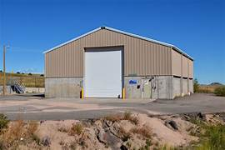

# Project Objective:

# To conduct a comprehensive structural analysis of our existing warehouse facility to assess its safety, integrity, and capacity for supporting current and future operational needs.

DESIGN AND SOFTWARE

The Steel structure is modelled in STAAD Pro with structural elements of varying section sizes to get an optimum design in valuable budget. The Main frame sidewall columns are provided with fixed supports and gable end columns are provided with pinned Supports. The bracings are considered to provide stability to the building in the longitudinal direction . The main steel structures are modelled and analysed as moment frame systems in the transverse direction to resist both gravity and lateral loads. The longitudinal bracing systems along the wall and the roof will function as the lateral load resisting system in longitudinal direction. The loadings and load combinations are considered as per standards . The modelling and analysis for primary steel frames is done in STAAD pro analysis software . The same software is also employed to perform the design of the sections. The bracing systems are ‘X’ bracings. The diagonal bracings are tension members only and the horizontal ties are compression members. The bracing elements are analysed and design using STAAD pro analysis software . In addition to the horizontal ties of the bracing system, additional ties are provided in the columns in longitudinal direction to reduce the effective length of the columns and provide lateral supports. The elements sizes are finalized according to the required sectional properties based on the analysis results to ensure the design safety and economic value. The wind load assumed in this model is based on the AISC standard because to highlight the differences in the AISC and IS Standard to find the optimum design methodology. The selection of various elements to perform the safe distribution of load acting on them to the soil safely are done with the reference and sources available. Since the total weight of the structural elements plays a role in cost and efficient design of structure, various iteration carried out in the selection of elements.

PROCEDURE:

1. Create a new project on staadpro software with length units as meter and weight units as kilonewton

2. Create the front view of the warehouse of height 6m in the grid of the software with 2 columns being 4 m each with 6m distance between them.

3. Select all the frames and add a transitional repeat on z-direction with no. of steps as 3 and spacing as 4, after that delete all the beam sections at the base.

4. Manually Add 2 bracings diagonally between each columns on both side of the model.

5. Go to top view of the model and select all the horizontal beam sections, after that use the funtion insert node to add 3 no. of nodes at each beam.

6. Select all the nodes created in step 5 and use the function connect beams along z axis.

7. Go to general tab to add the section database of steel. Add the IW 350300x010, IW 350300x012, ISA 100x100x15 of indian standard.

8. Assign the the 350300x10 section to all the horizontal members, border vertical members and center vertical members on the topview of the model.

9. Similarly Assign 350300x012 sections to the columns and finally assign the 100x100x15 section to all the remaining beams.

10. Create the fixed supports for all the nodes at the base of the model.

11. Add seismic definition with the type as 'IS 1893 - 2002/2005' and choice as 'zone iv'. Set the soil type to 'medium soil' with damping ratio of 0.05% and structure type to 'steel framed building', add this with self weight as 1.

12. Add 2 load case of seismic loading type and name them as EQ x and EQ z, 1 dead loading type and name it as DL and finally 1 live loading type with the name as LL.

13.Add EQ x and in factor direction let it be x direction with factor 1, in the same way Add EQ z but in z direction with factor 1.

14. Add the dead load and set self weight on y direction with factor -1 and assign it to view, same way add the live load and set the nodal load on Fy as -20kN and assign it to view.

15. Select the load case details and add auto load combination as per indian code and generate. In the material section, select steel and assign it to view.

16. Then finally analyze the load by clicking "run analysisAnd check if any errors are occuring

MODELLING:

C/C DISTANCE FROM COLUMN TO COLUMN IN FRONT VIEW IS 6m.

C/C DISTANCE FROM COLUMN TO COLUMN IN SIDE VIEW IS 4m.

3-D VIEW:

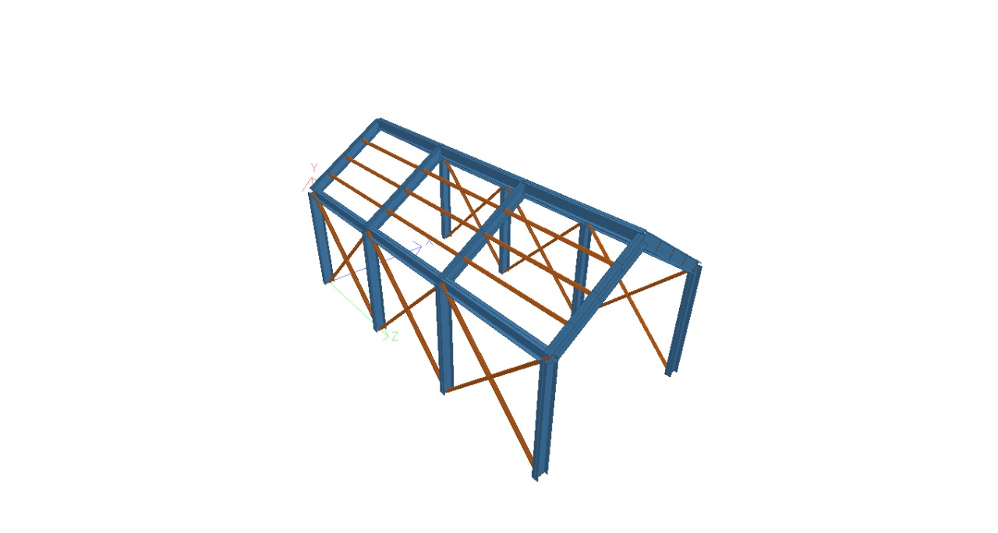

Fig 1a

2-D VIEW:

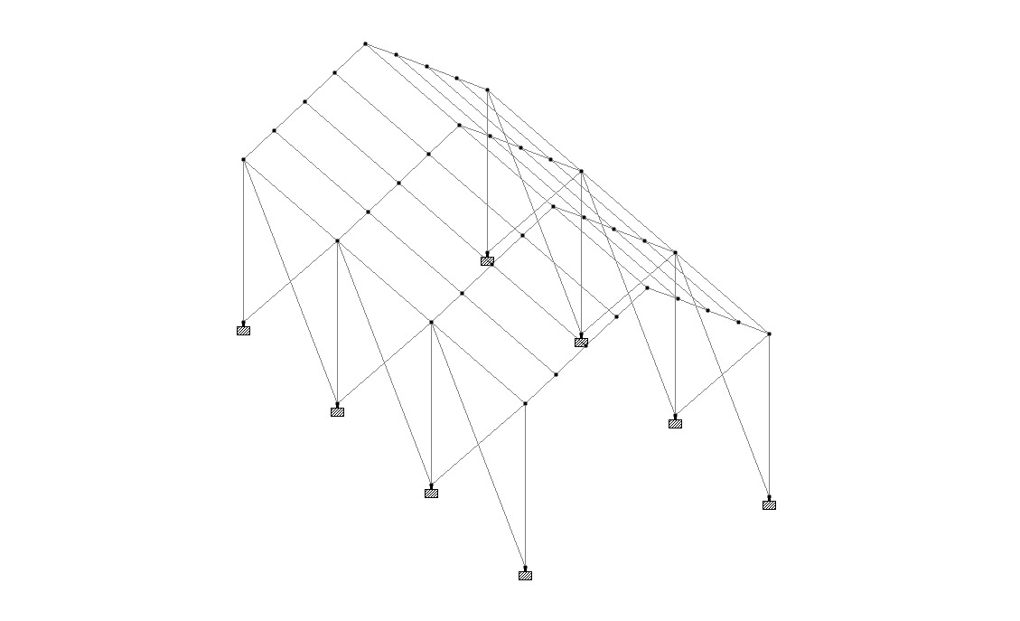

Fig 1b

FRONT VIEW:

3-D:

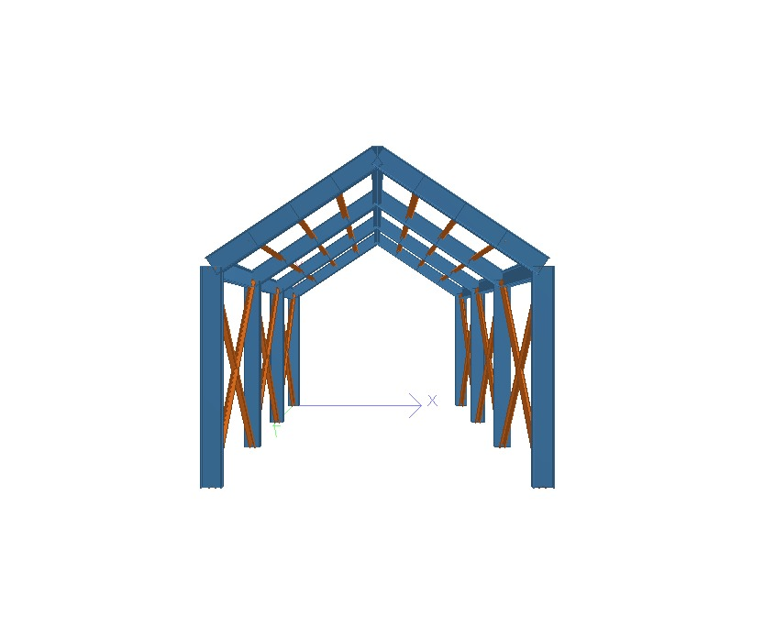

Fig 2a

2-D: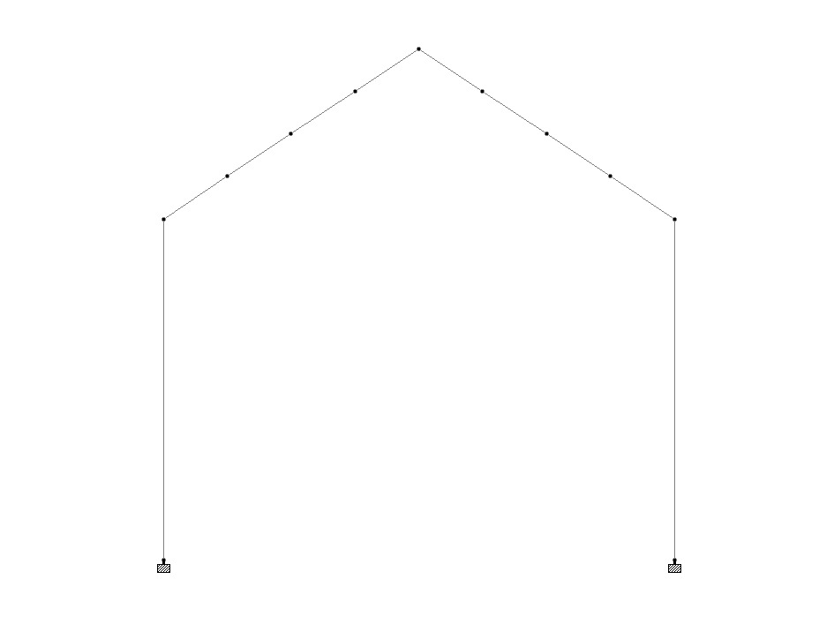

Fig 2b

SIDE VIEW:

3-D:

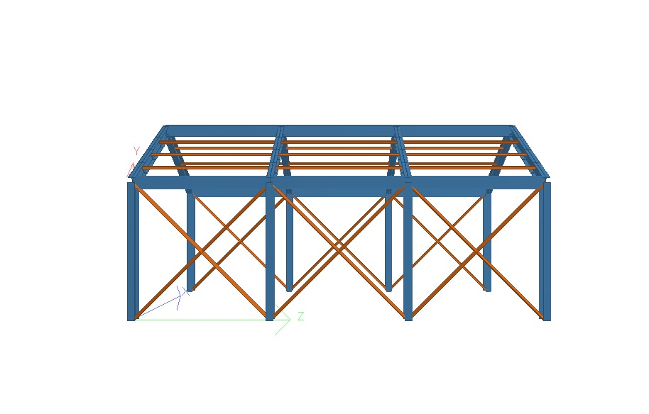

Fig 3a

2-D: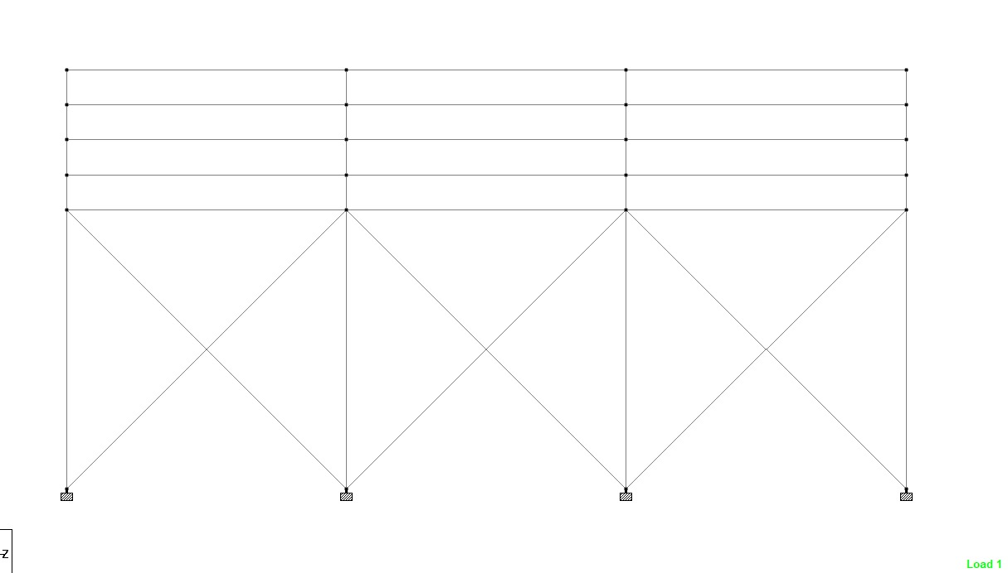

Fig 3b

TOP VIEW:

3-D:

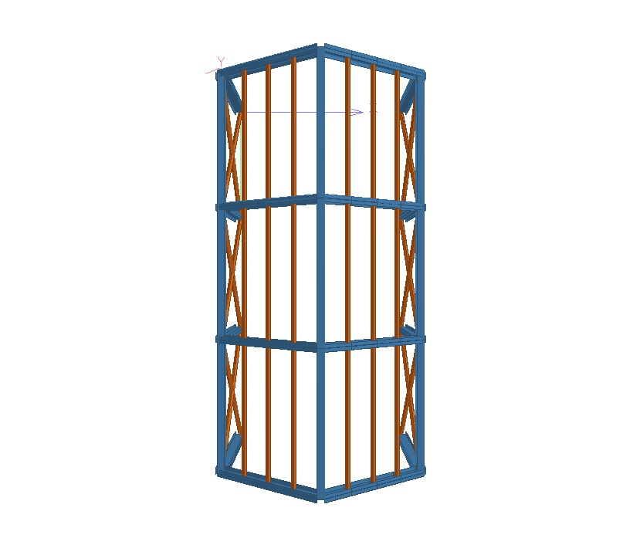

Fig 4a

2-D:

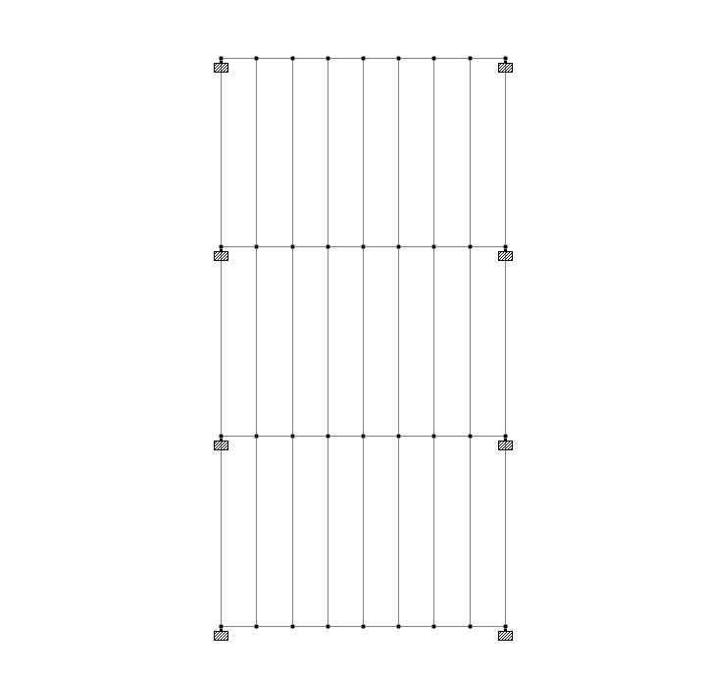

Fig 4b

SECTION DESIGN:

Fig 5a

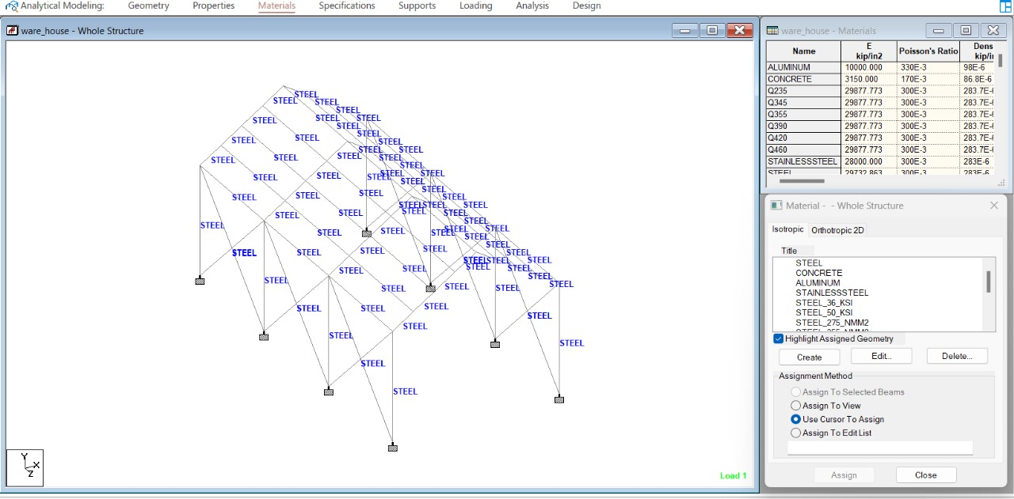

Fig 5b

LOAD:-

The load acting here are live load, dead load, seismic load and earthquake load. The intensity of these loads are according to Indian Standards.

As according to Indian Standards if the height of the structure is less than 10 metres then wind load is not much effective. As the height of this warehouse is 6 metres, we are not consider wind load here.

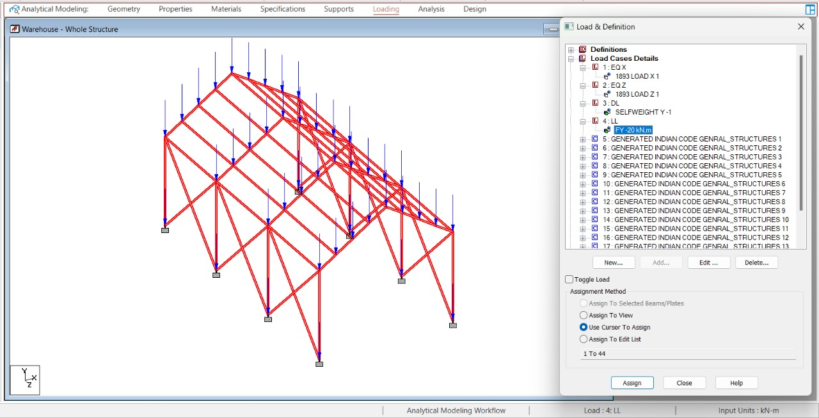

Fig 6

ANALYSIS OF PARTICULAR BEAM:

PROPERTY AND DESIGN STRENGTH OF BEAM 24:

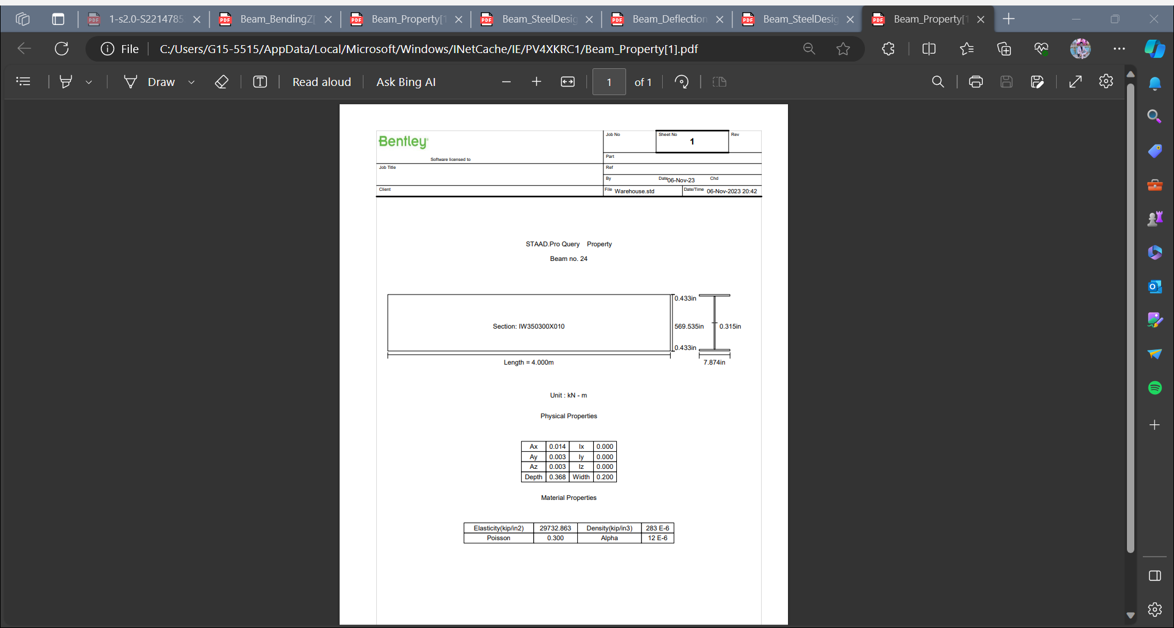

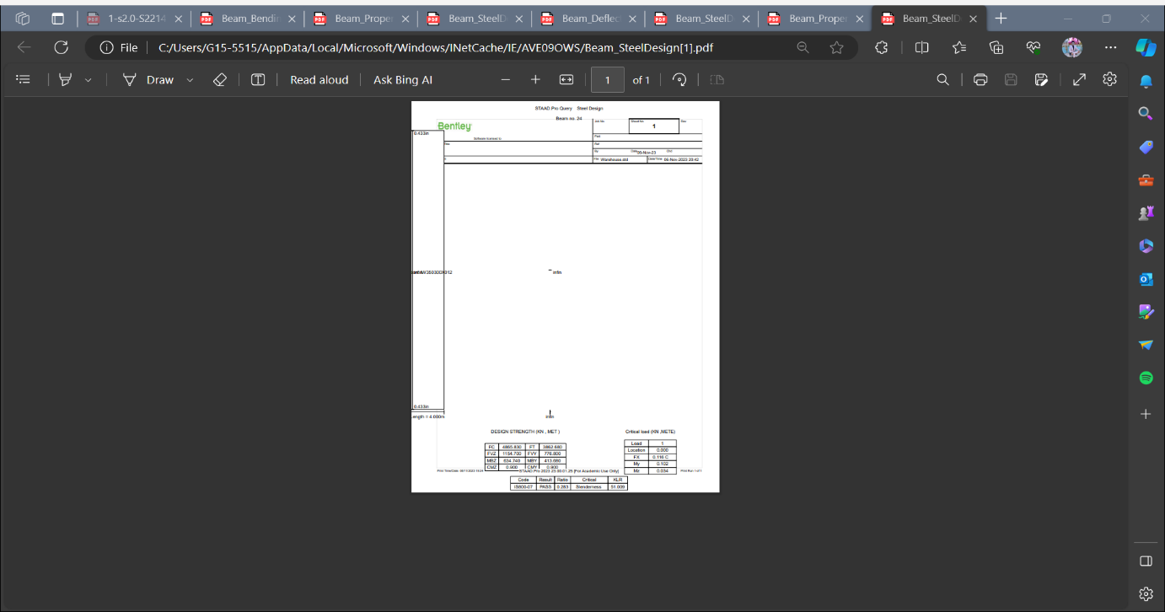

Bending Moment about z axis of beam 24:

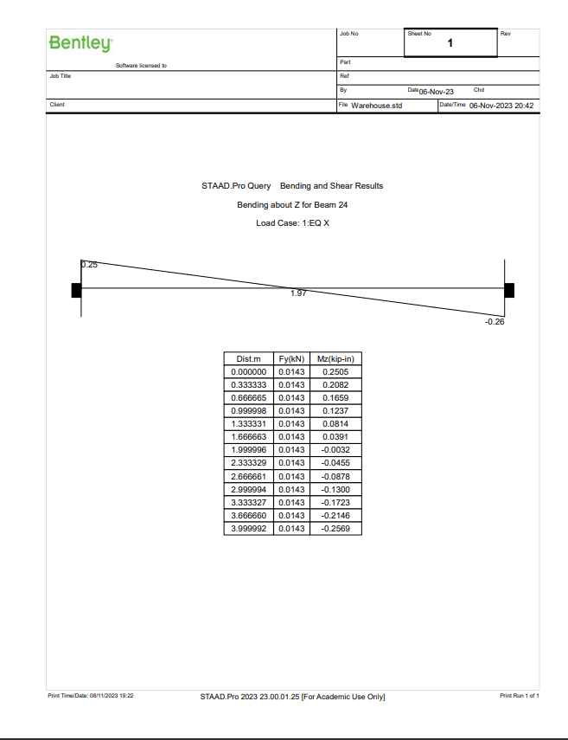

Deflection of beam 24:

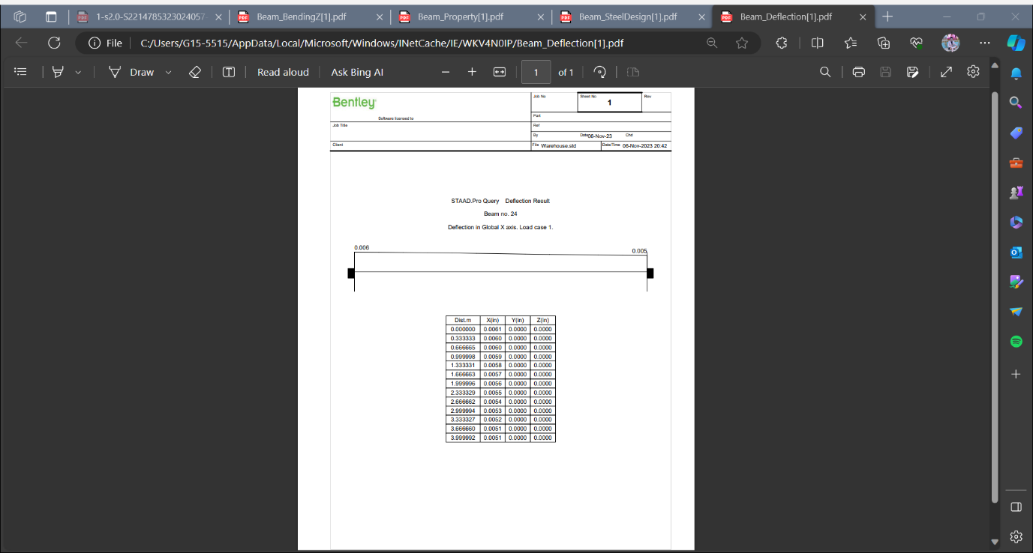

ANALYSIS OF PARTICULAR COLUMN:

PROPERTY AND DESIGN STRENGTH OF COLUMN(28):

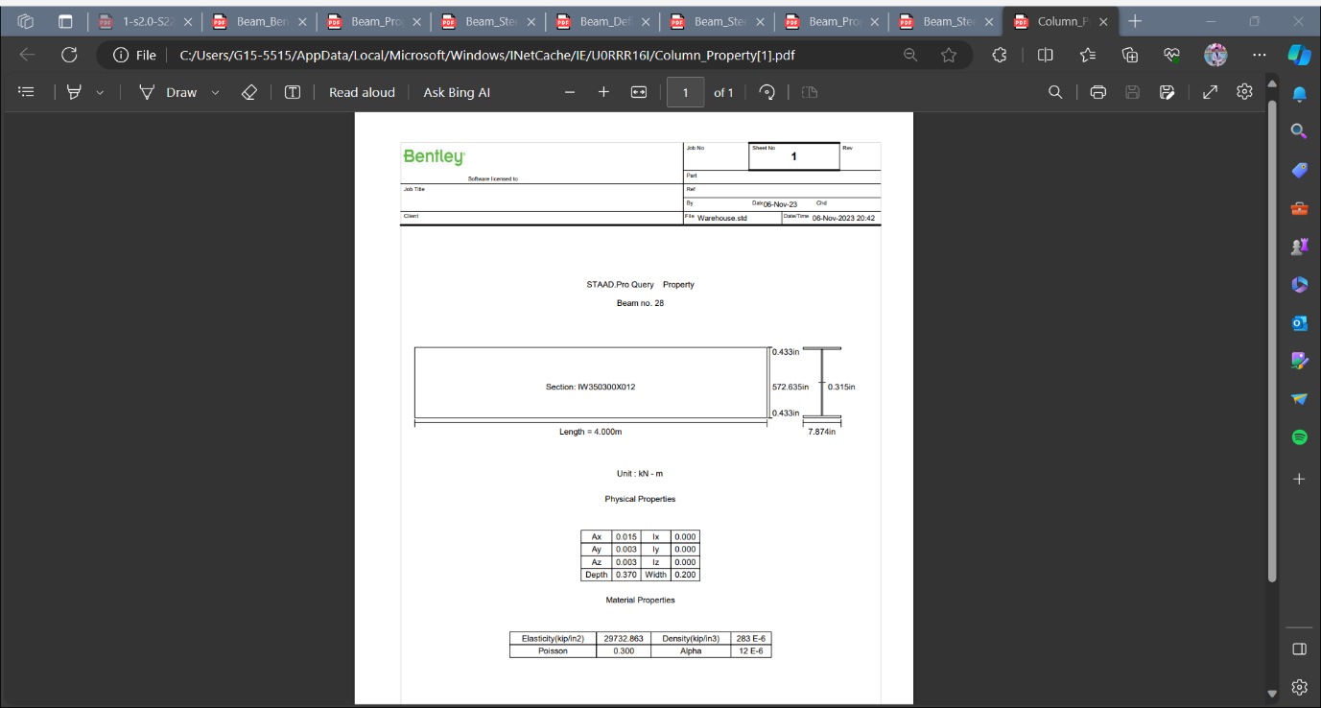

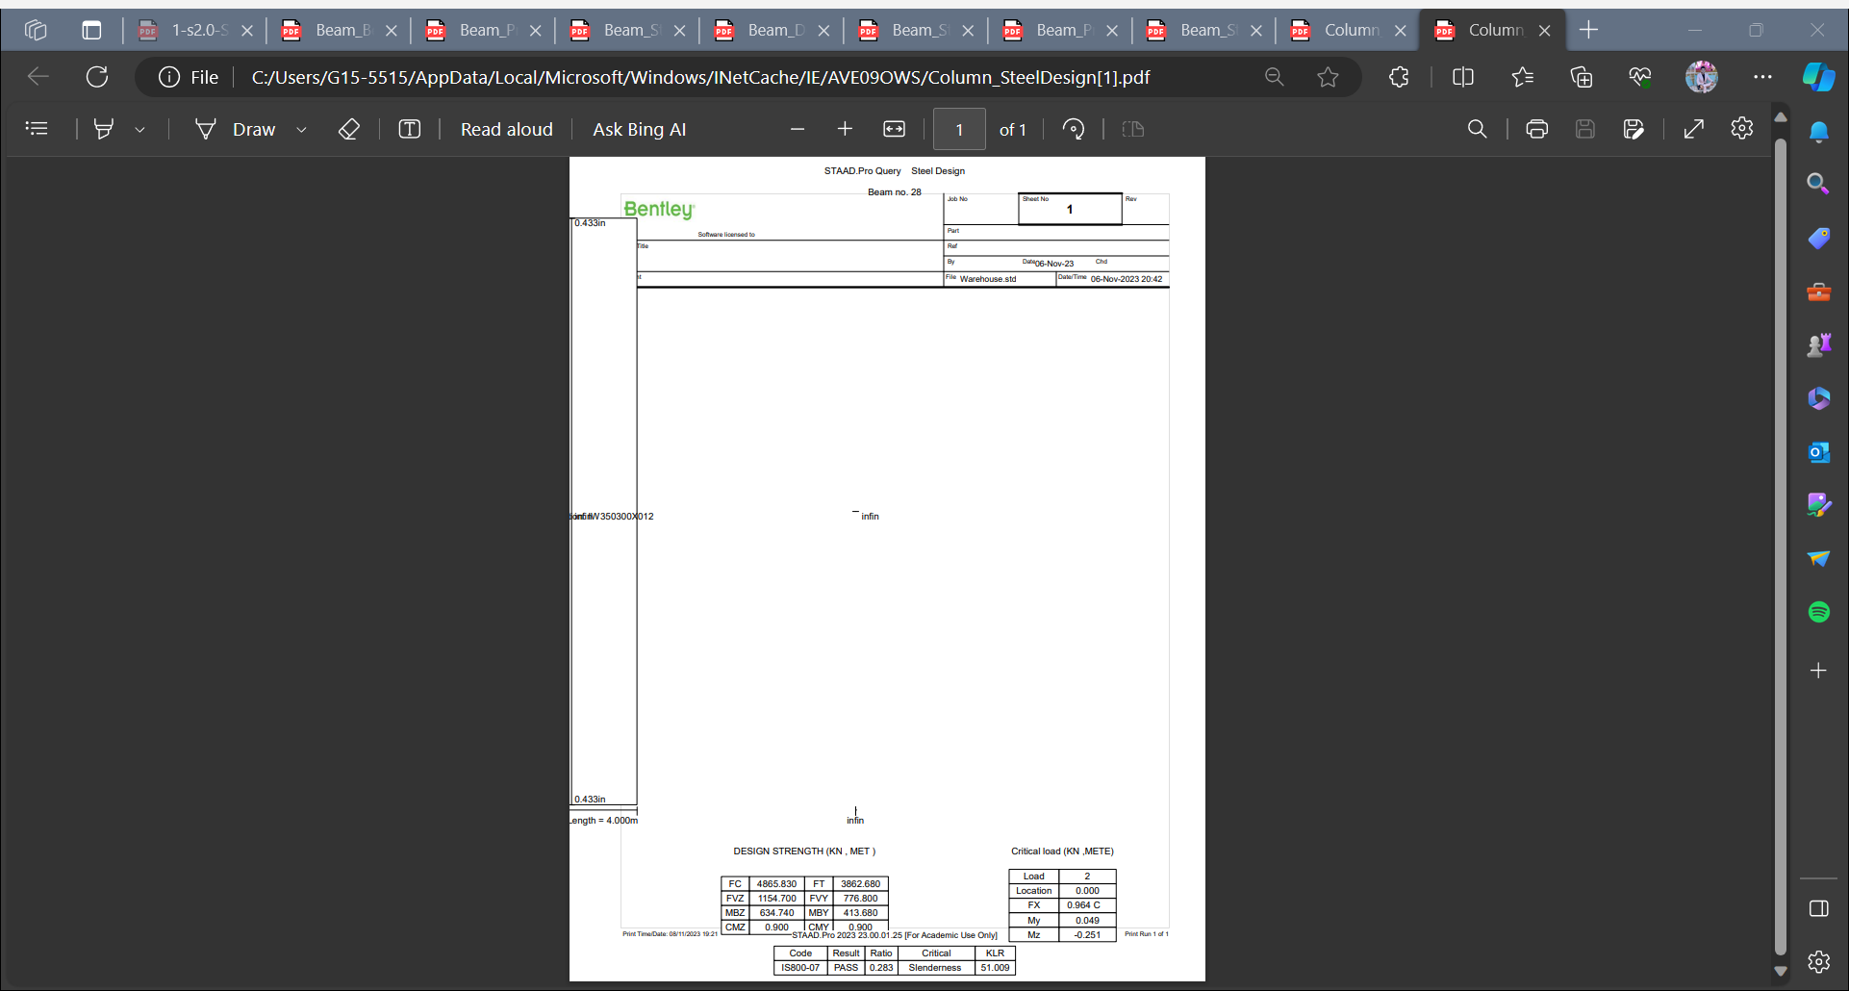

Bending Moment about z axis of COLUMN(28):

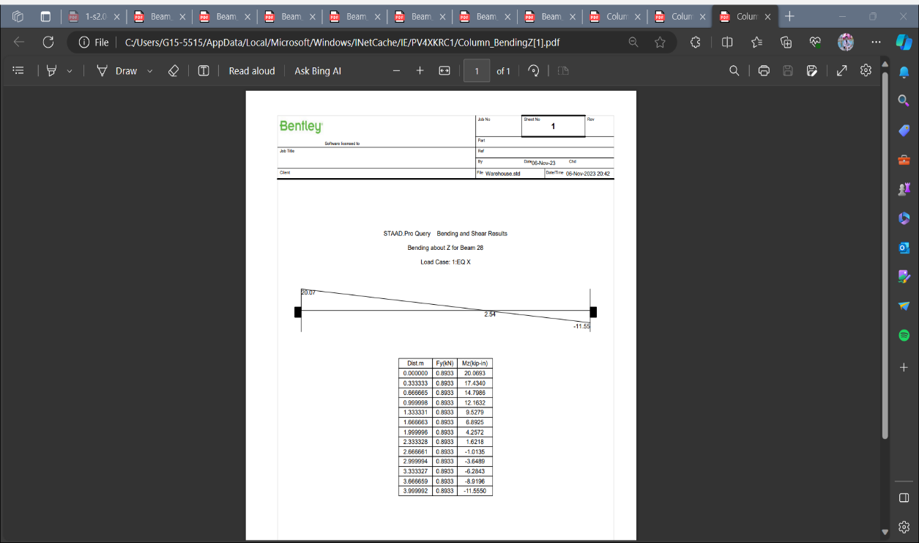

Deflection of column(28):

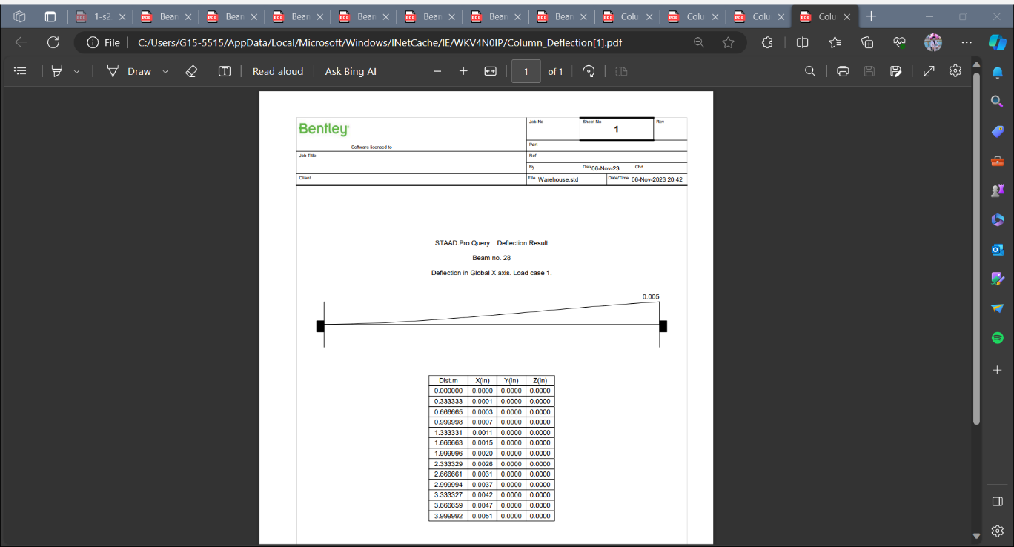

ANALYSIS OF DIAGONAL BEAM:

PROPERTY OF DIAGONAL BEAM:

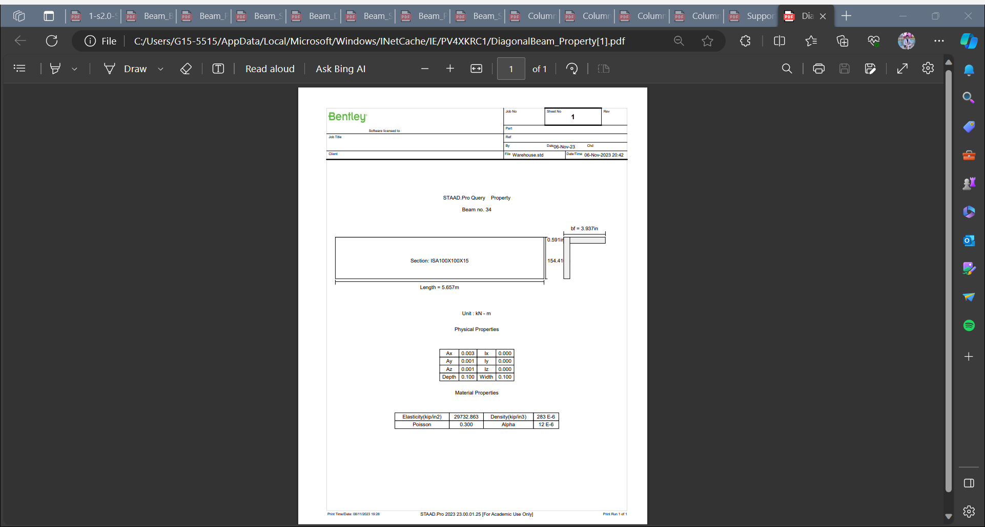

DEFLECTION IN DIAGONAL BEAM:

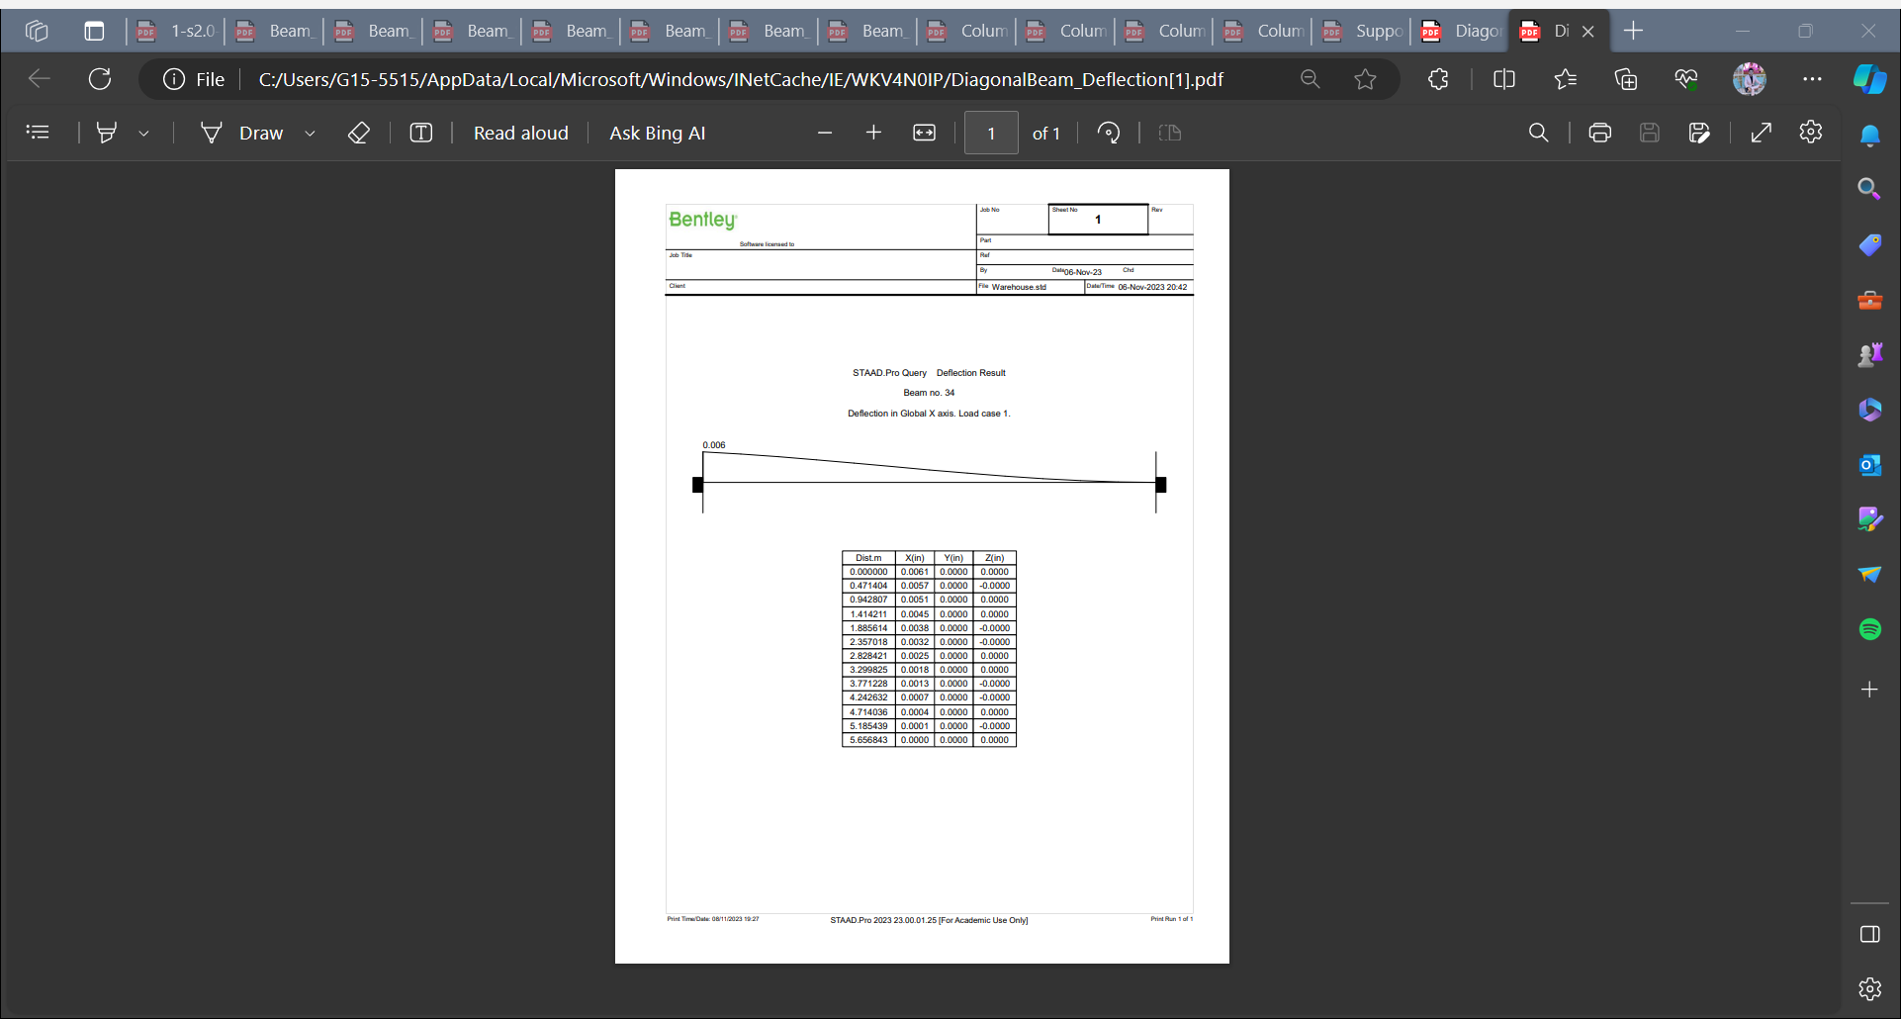

BENDING ABOUT Z-AXIS IN DIAGONAL BEAM:

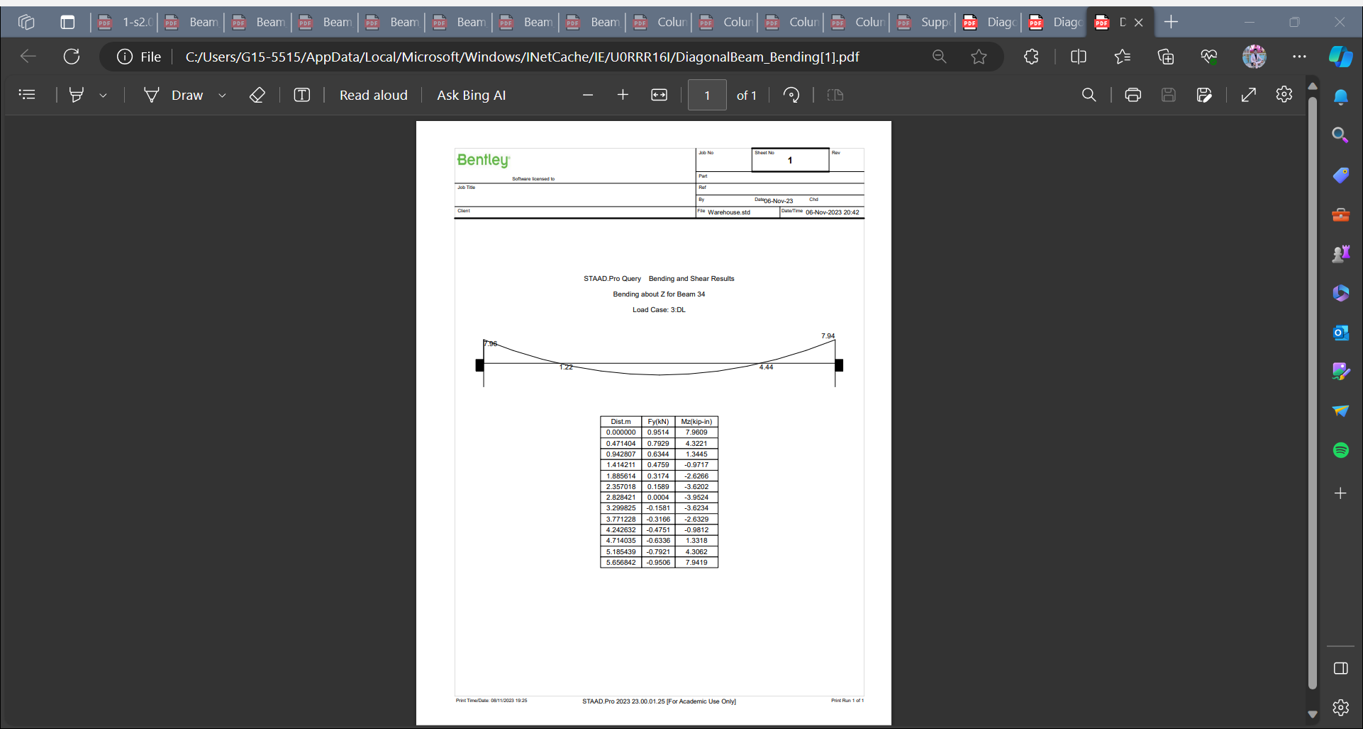

OVERALL SFD AND BMD DUE TO EARTHQUAKE LOAD (EQ Z):

SFD:

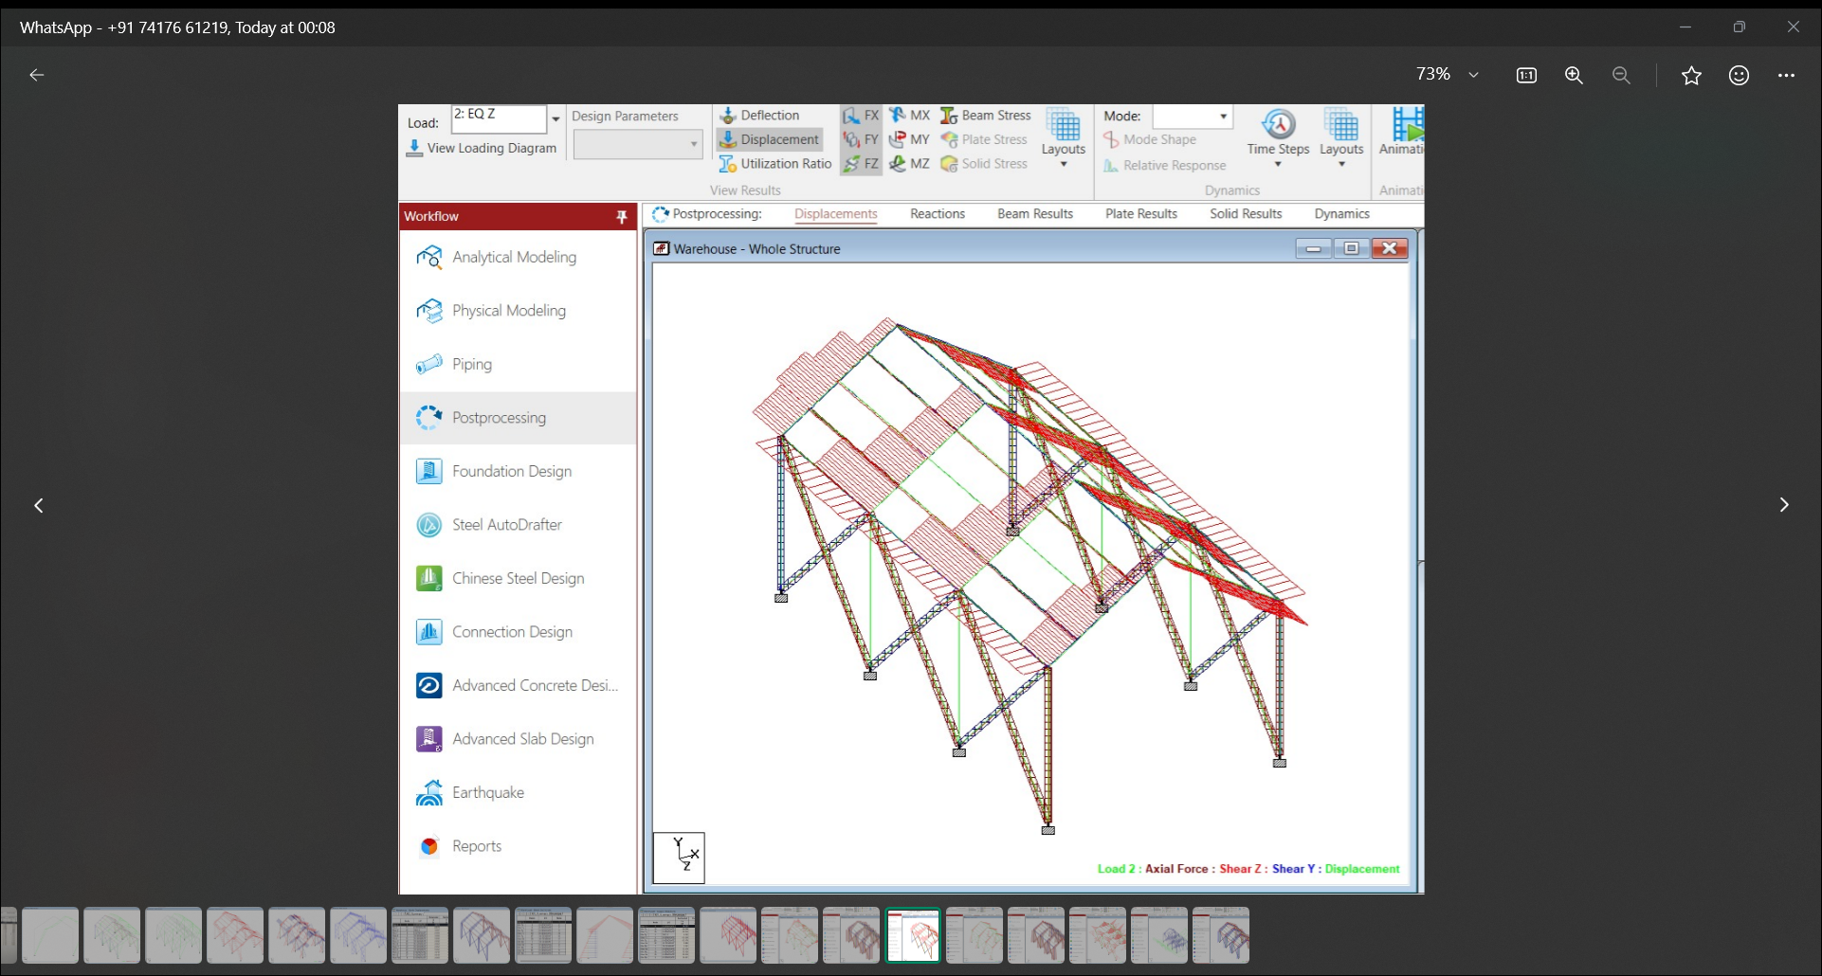

Fig 7a

BMD:

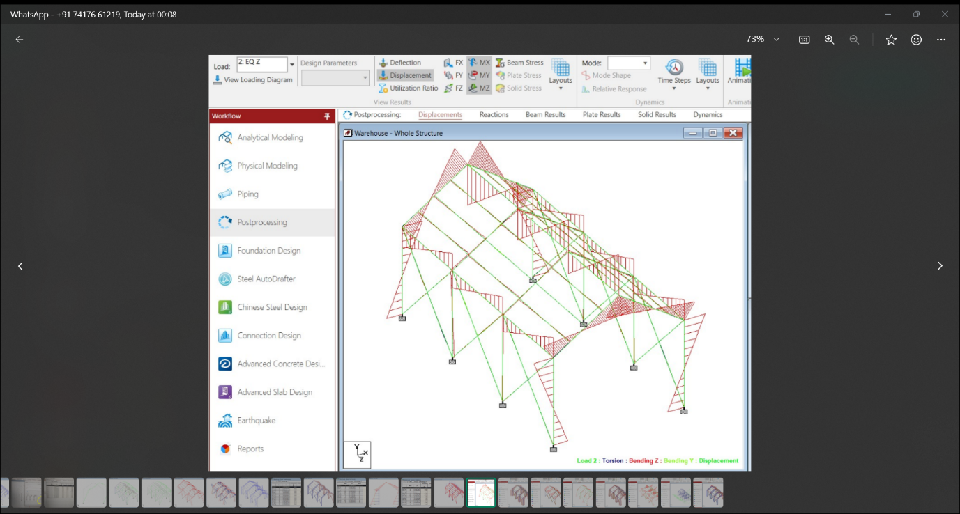

Fig 7b

OVERALL SFD AND BMD DUE TO EARTHQUAKE LOAD (EQ X):

SFD:

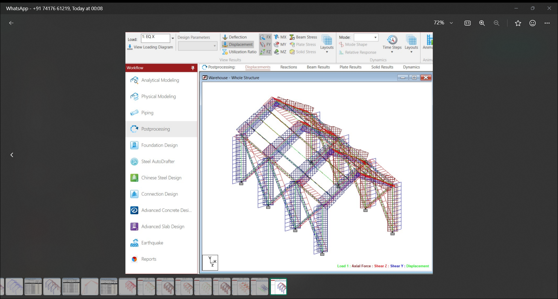

Fig 8a

*BMD:*

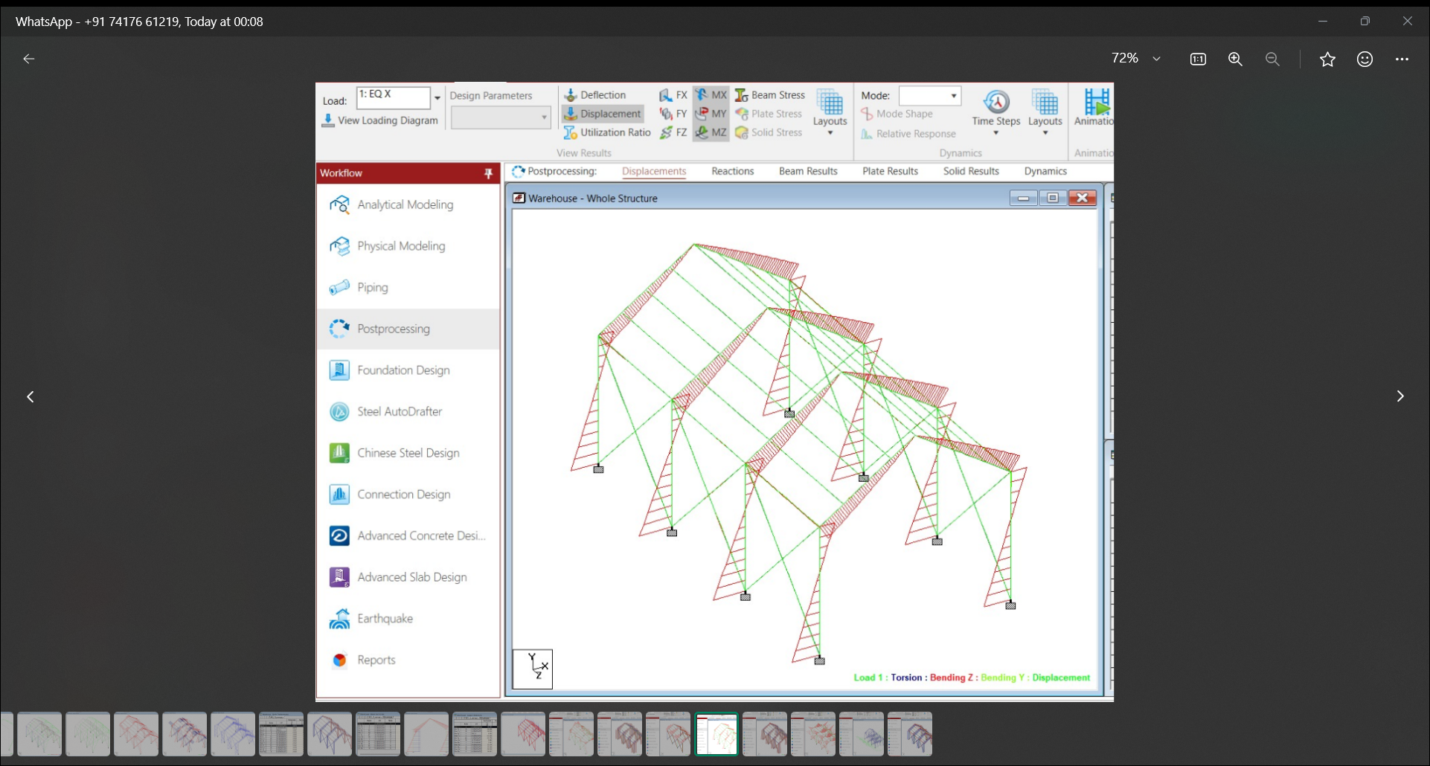

Fig 8b

OVERALL SFD AND BMD DUE TO LIVE LOAD:

SFD:

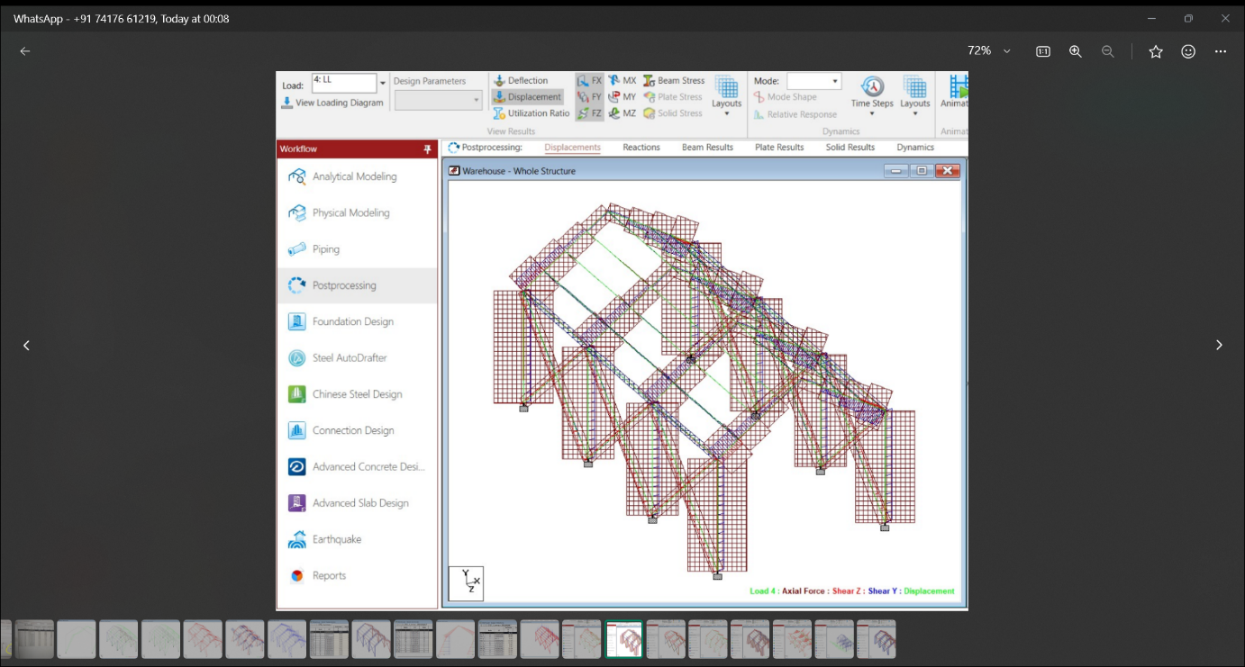

Fig 9a

*BMD:*

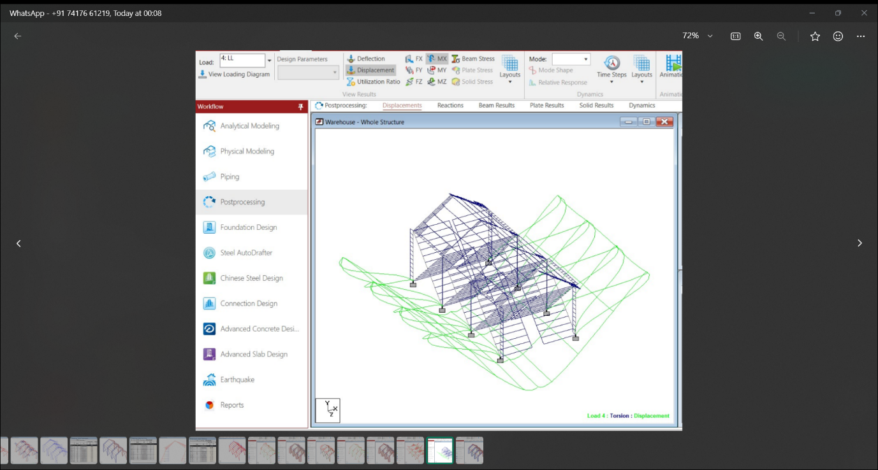

Fig 9b

OVERALL SFD AND BMD DUE TO DEAD LOAD:

*SFD:*

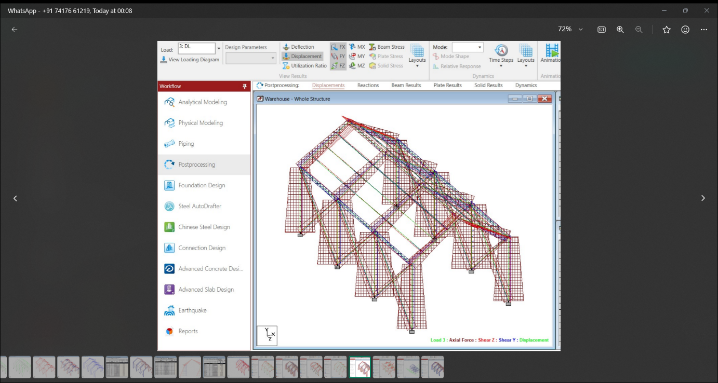

Fig 10a

*BMD:*

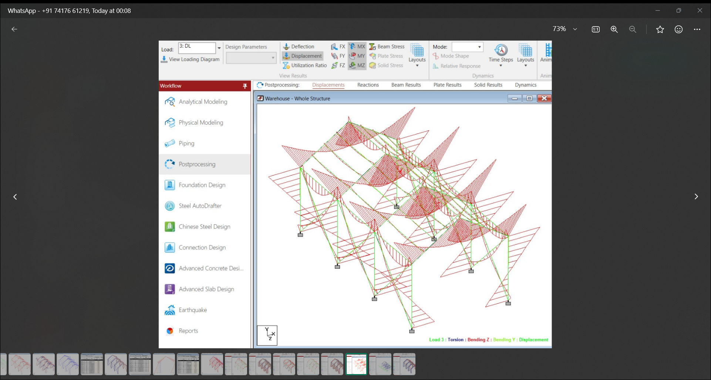

Fig 10b

*REACTION :*

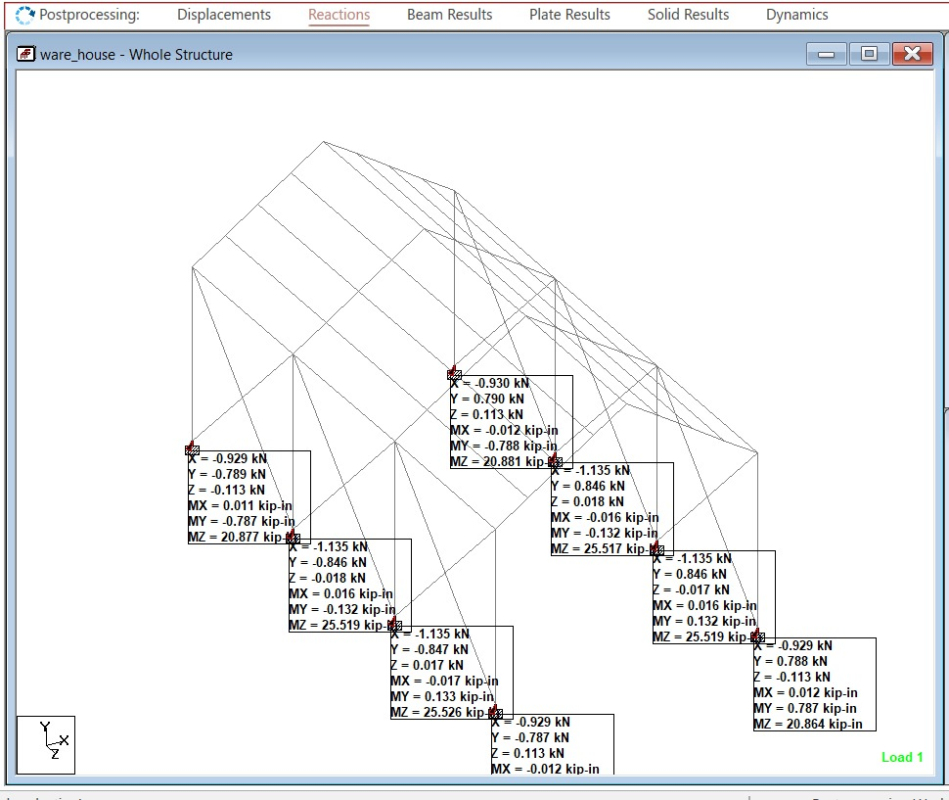

Fig 11

*BEAM RESULTS:*

*DUE TO DEAD LOAD:*

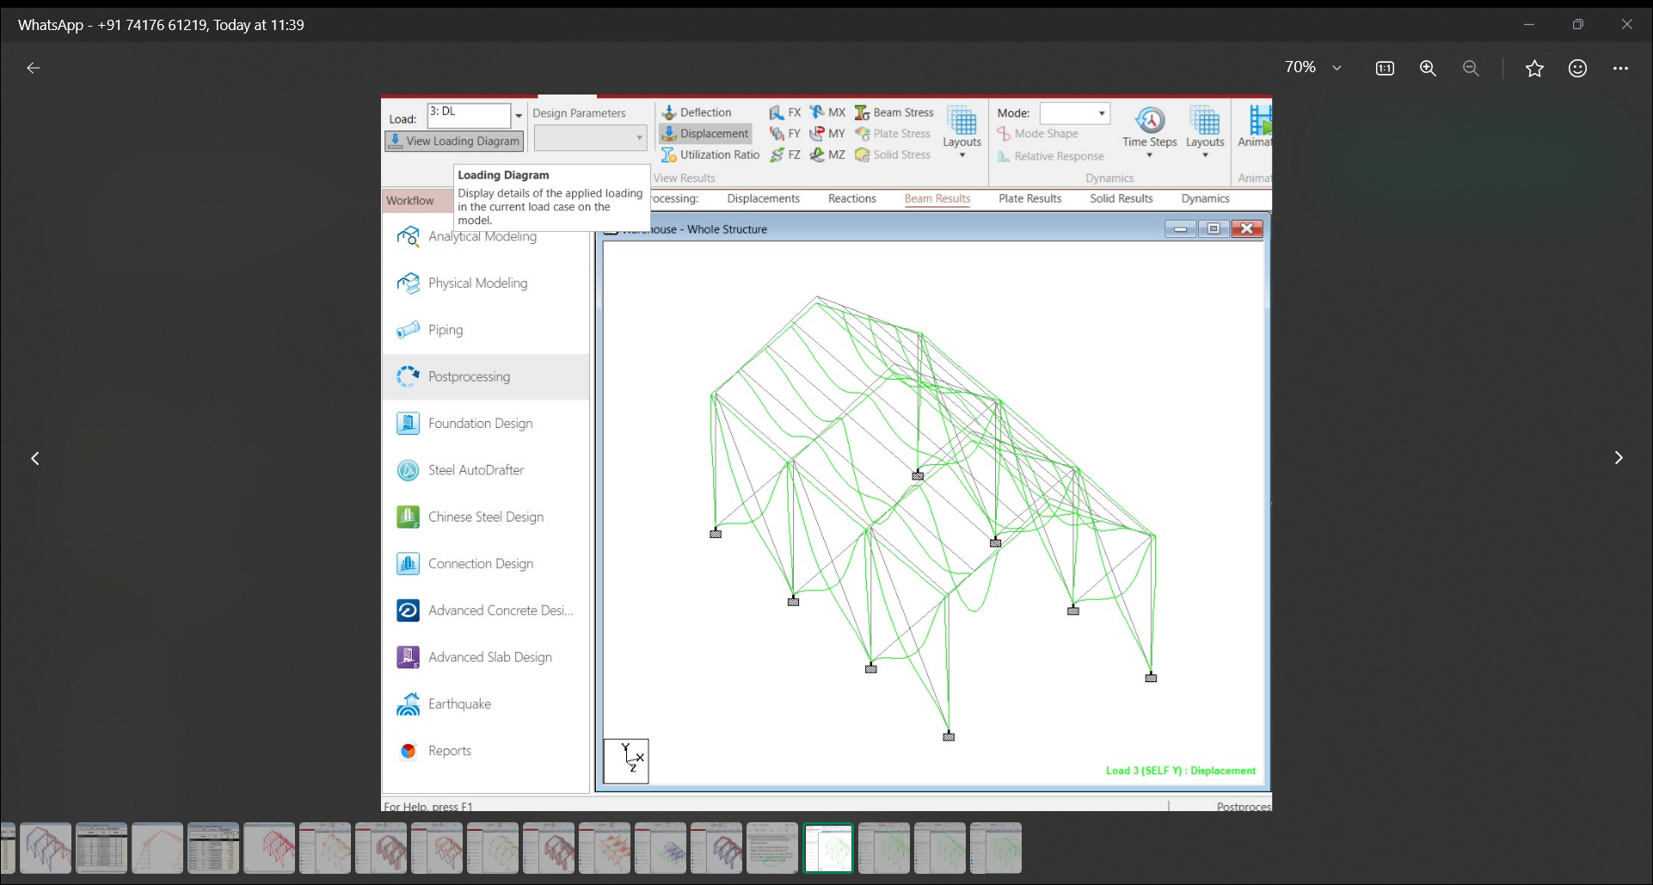

Fig 11a

*DUE TO LIVE LOAD:*

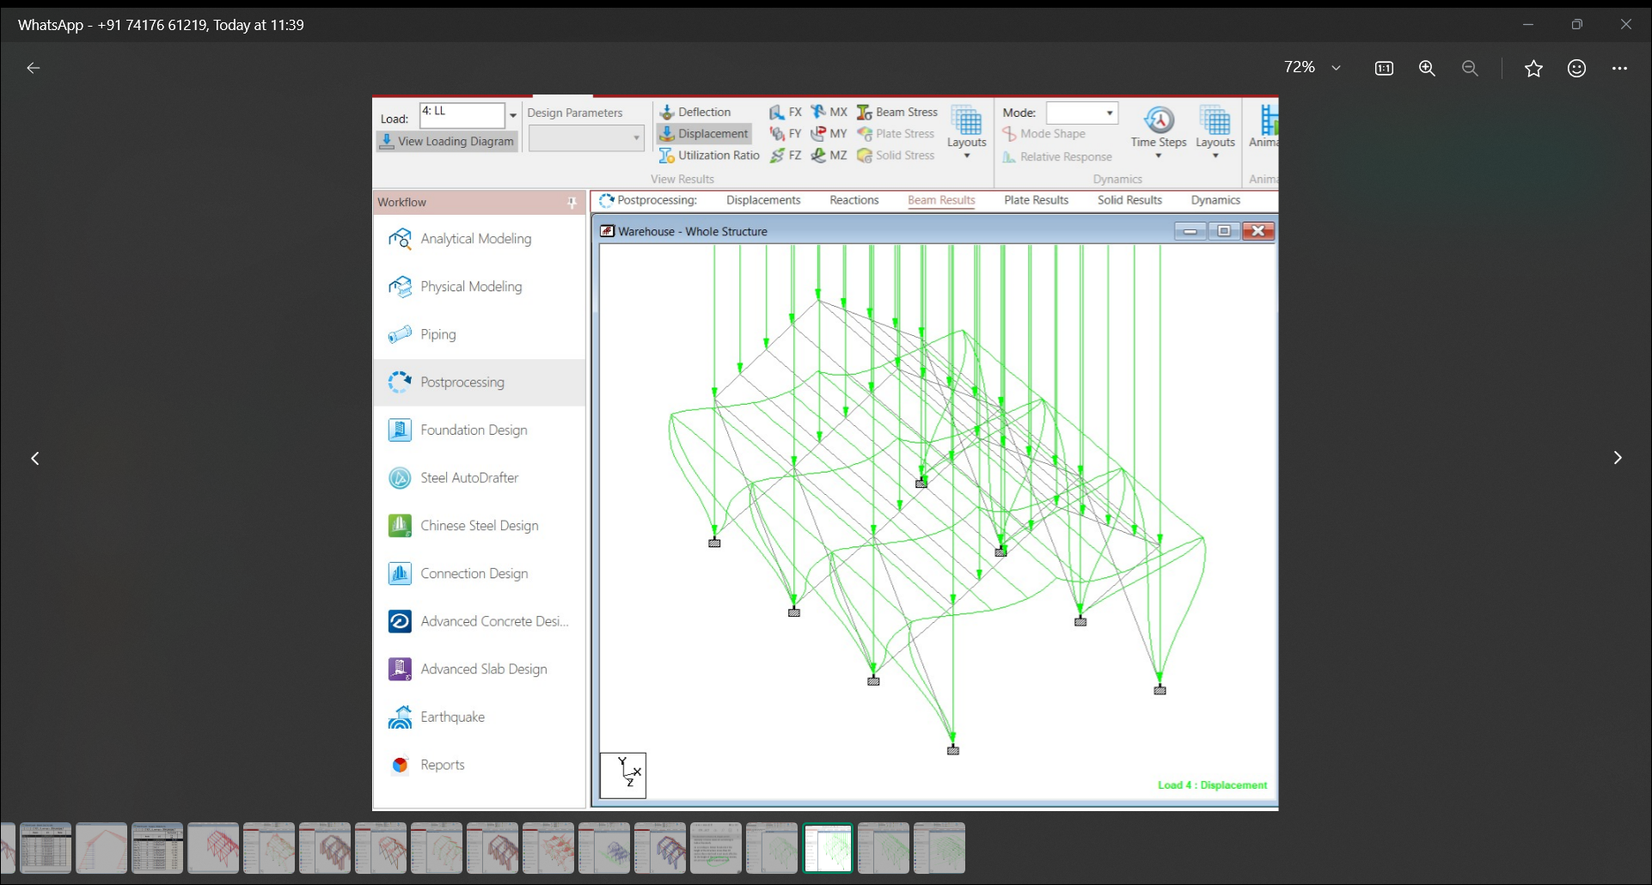

Fig 11b

*DUE TO EARTHQUAKE LOAD (EQ X):*

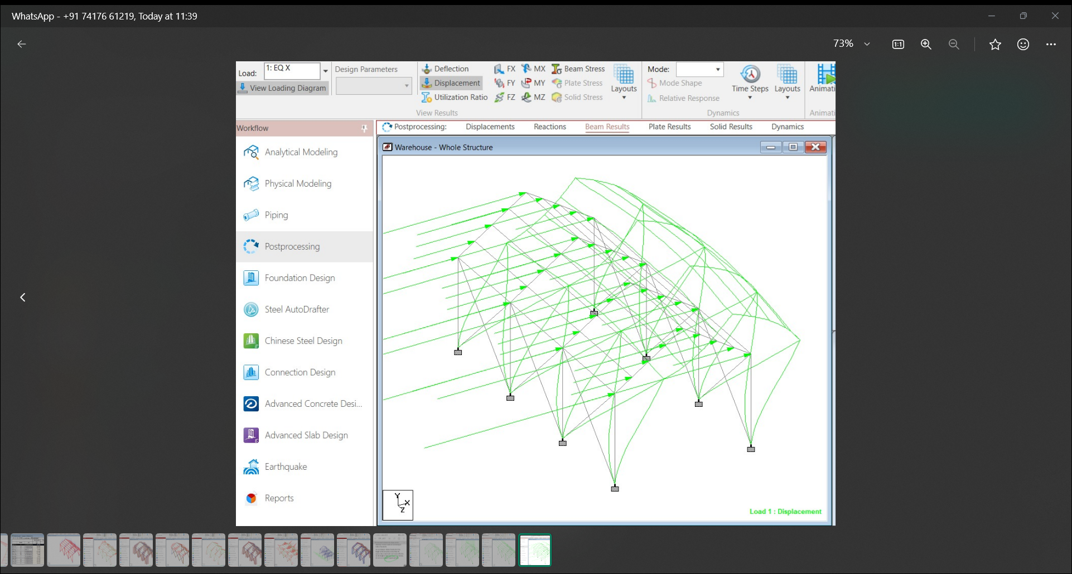

Fig 12a

*DUE TO EARTHQUAKE LOAD (EQ Z):*

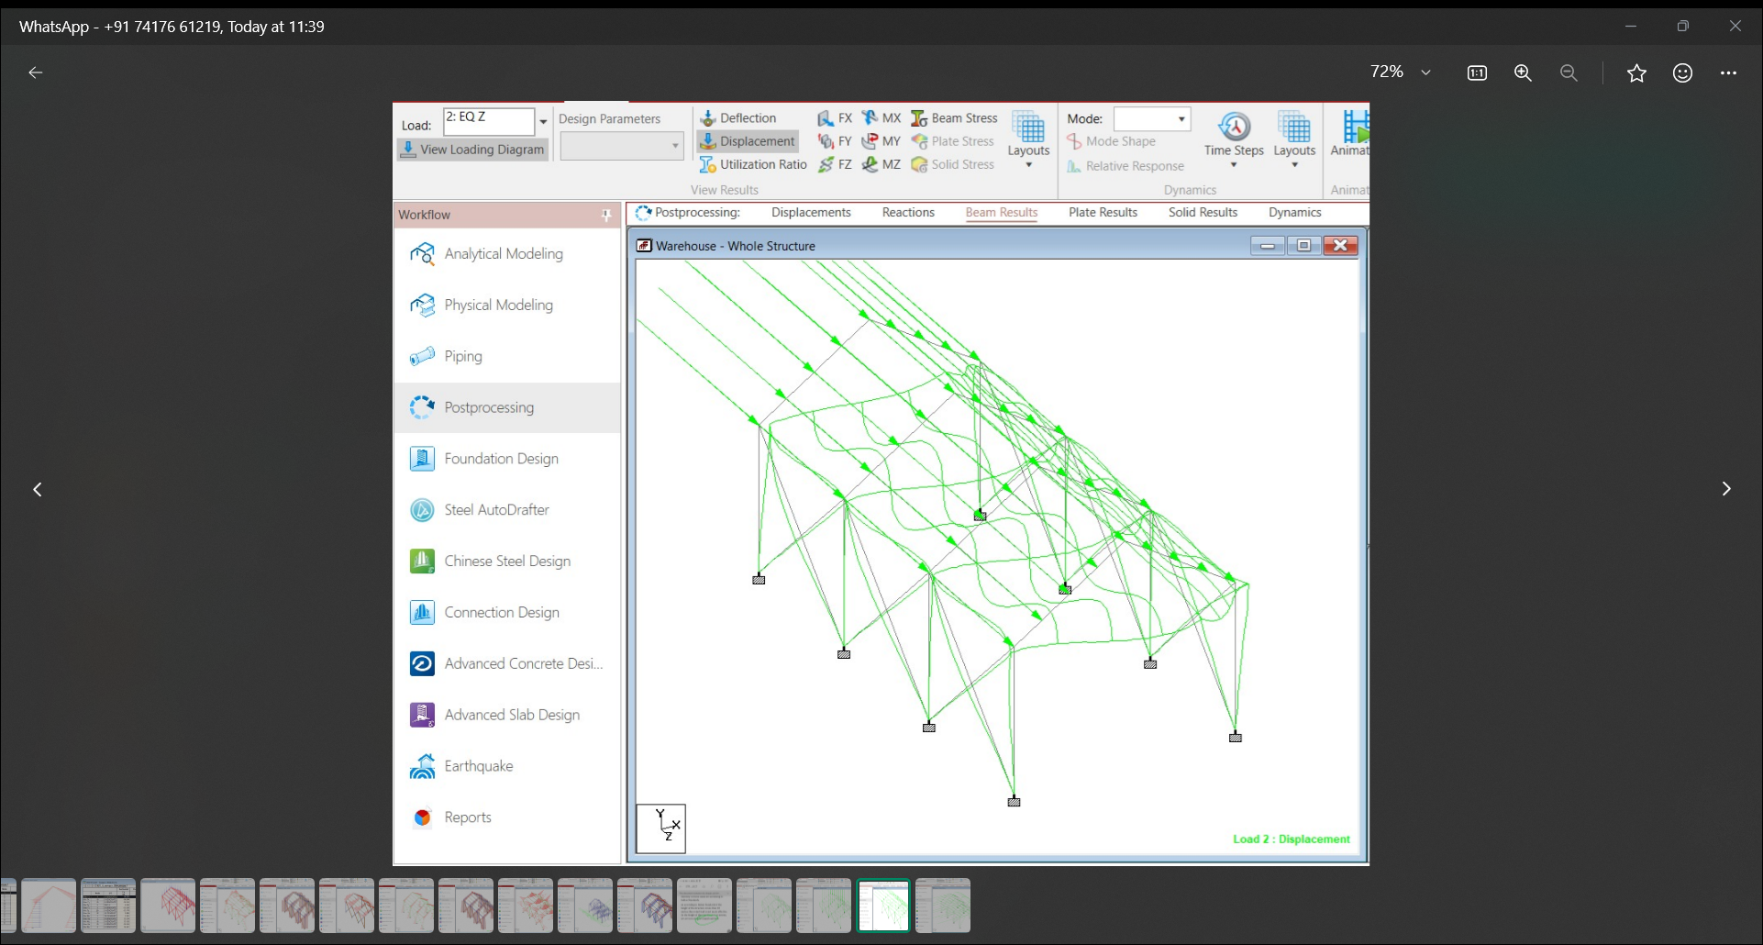

Fig 12b

*Result and discussion:*

From the above analysis the result obtained from the STAAD for different load combination is tabulated below. It is found that the structure is governed by wind load combination (DL + WL). Hence the design is based on combination of maximum axial load with respective moments and maximum moments with respective axial force . Designed elements satisfy the code requirements for limit state of collapse and serviceability for all other combinations. Connection design can be done with help of the result obtained from the nodal displacement values from post processing. Utilization factor limits for all members were within the range of 0.7–0.8. The design is optimized to its extent. The choice of purlin made of different factors including high strength-to-weight ratio, versatility, easy to install, resistance to weathering and sustainability.

*CONCLUSION:*

The following are the major observation and conclusion drawn from the present project work.

* The steel warehouse is analysed for the respected loads acting on the structure as per the codes.
* The warehouse structure is analysed for the different load combinations.
* The materials quantity is calculated for the optimized design of the structure.